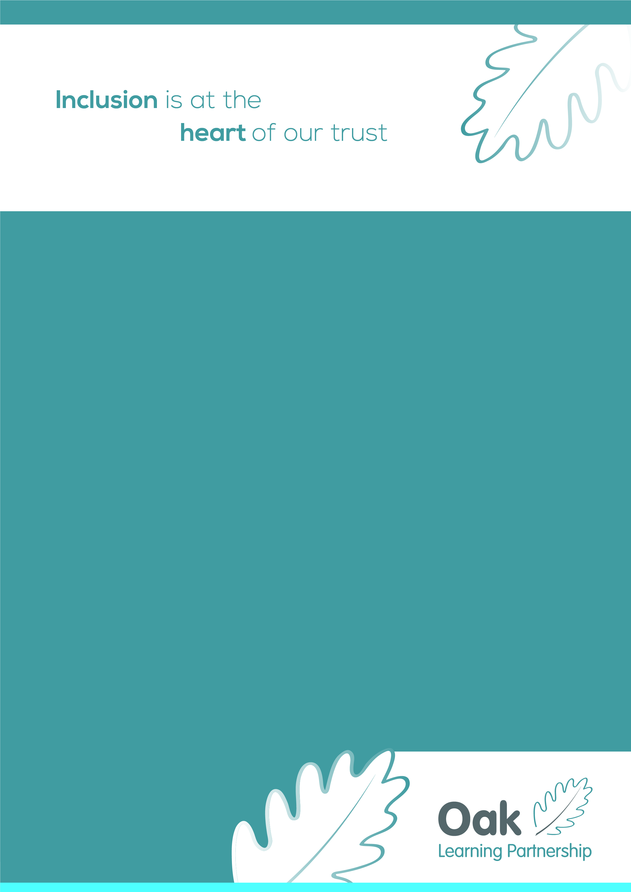
Wellbeing for everyone in Education

🌟 Wellbeing for Everyone in Education 🌟
Support strategies for Headteachers, SENCOs & Teachers

✨ For Everyone
1. Set Boundaries
▫️ Define work hours & stick to them
▫️ Avoid checking email after hours
2. Take Microbreaks
▫️ Stretch, hydrate, breathe
3. Simplify & Delegate
▫️ Use templates for repeat tasks
▫️ Delegate where appropriate
4. Celebrate Small Wins
▫️ Keep a positivity file
▫️ Reflect on one good thing daily
5. Stay Connected
▫️ Build staff relationships
▫️ Use staffroom time to connect — not just vent!

🧠 Headteachers
1. Model Wellbeing
▫️ Leave on time once a week
▫️ Share your own wellbeing habits
2. Prioritise Staff Wellbeing
▫️ Cut unnecessary meetings — could it be an email?
▫️ Schedule regular wellbeing check-ins (with staff and yourself!)
3. Delegate Smartly
▫️ Empower middle leaders
4. Foster a Safe Culture
▫️ Create space for honest conversations

🧹 SENCOs
1. Smart Caseload Management
▫️ Use simple tracking tools
▫️ Schedule proactive reviews
2. Time Block Focus Tasks
▫️ Protect time for paperwork
3. Buffer After Heavy Meetings
▫️ Plan recovery time
4. Know When to Signpost
▫️ Use external support networks wisely

👩‍🏫 Teachers
1. Weekly, Not Daily, Planning
▫️ Batch plan & mark lessons
2. Prep a Go-To Toolkit
▫️ Keep easy-to-run activities on hand
3. Protect Your Breaks
▫️ Step away from your desk at lunch

🌿 Wellbeing Boosters
✅ Prioritise sleep & limit evening screen time
✅ Get outside daily — sunlight lifts mood
✅ Practice weekly gratitude
✅ Reach out — don’t go it alone
✅ Make a happy playlist or play a podcast on your commute
✅ Try a done list — celebrate what you’ve completed!

